**CRM-ANALYTICS SQL REPORT**

**Lead KPI’s**

1. **Total Lead**

SELECT count(`Lead ID`) as total_leads FROM leads ;

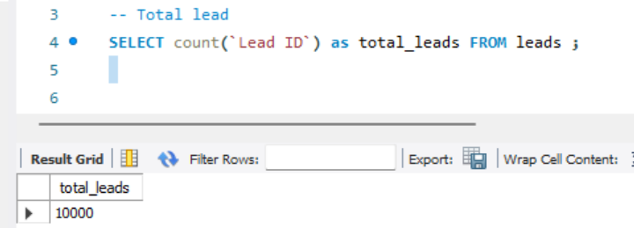

1. **Expected Amount from Converted Leads**

SELECT SUM(CAST(REPLACE(REPLACE(o.`Expected Amount`, ',', ''), '$', '') AS DECIMAL(20, 2))) AS Total_Expected_Amount_Converted_Leads

FROM opportuninty o

Right JOIN

Leads l ON o.`Opportunity ID` = l.`Converted Opportunity ID`

WHERE

l.`Converted` = 'True';

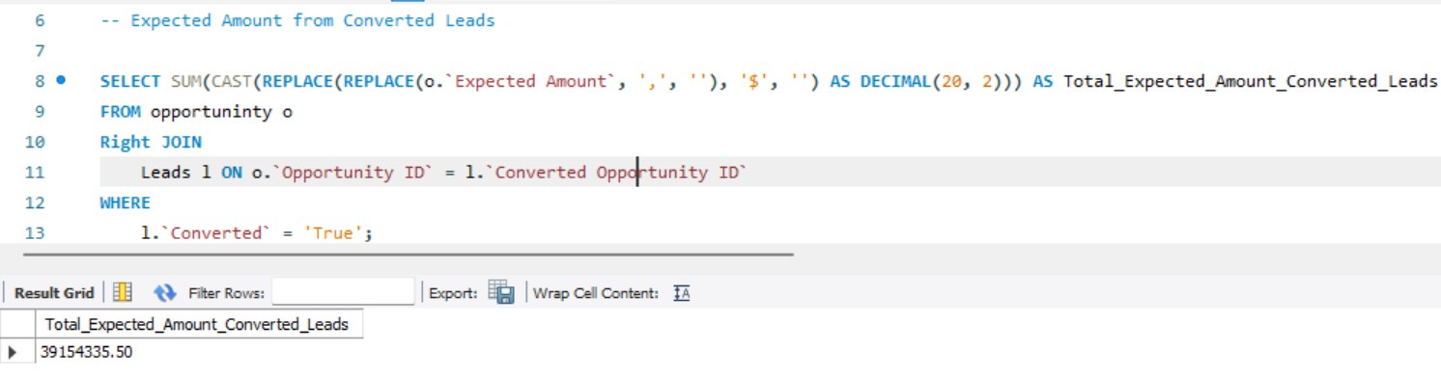

1. **Conversion Rate**

SELECT

(SUM(CASE WHEN Converted1 = '1' THEN 1 ELSE 0 END) * 100.0) / COUNT(*) AS Conversion_Rate_Percentage

FROM leads;

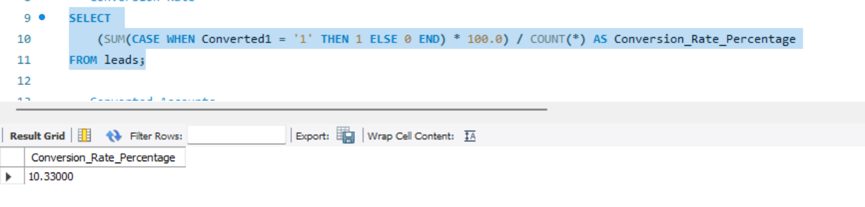

1. **Converted Accounts**

SELECT COUNT(*) AS Converted_Accounts

FROM leads

WHERE Converted1 = 1;

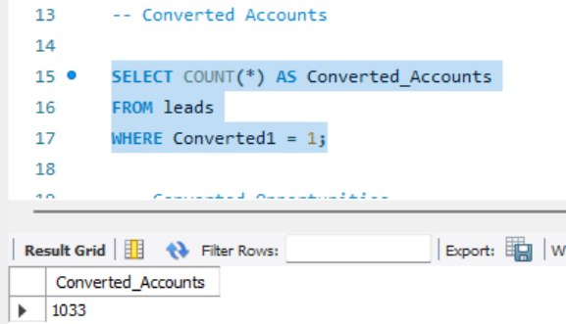

1. **Converted Opportunities**

SELECT

(SUM(CASE WHEN `# Converted Opportunities` = '1' THEN 1 ELSE 0 END))as Converted_Accounts

FROM leads;

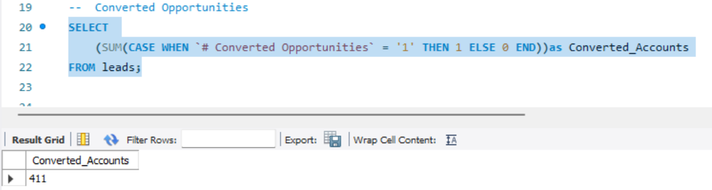

1. **Lead By Source**

SELECT Lead_Source, COUNT('Total Leads') AS Lead_Count

FROM leads

GROUP BY Lead_Source;

-- change name

ALTER TABLE leads

CHANGE `Lead Source` Lead_Source TEXT;

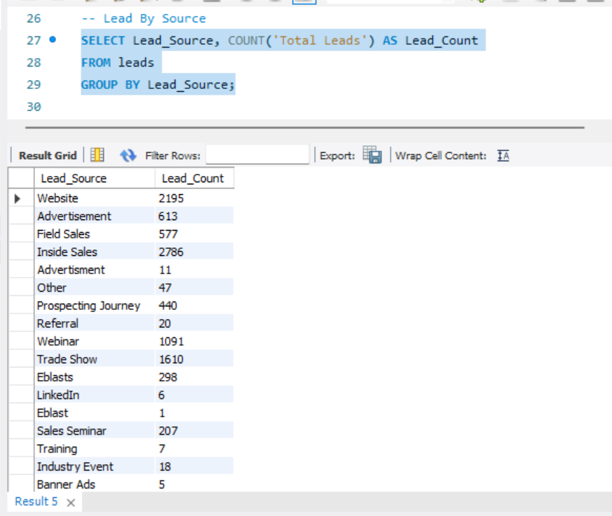

1. **Lead By industry**

SELECT Industry, COUNT('Total Leads') AS Lead_Count

FROM leads

GROUP BY Industry

order by Lead_Count DESC;  
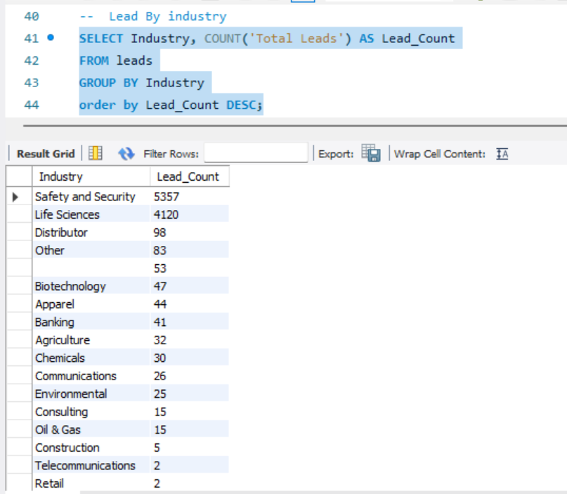

**Opportunity KPI’s**

1. **Expected Amount**

SELECT SUM(CAST(REPLACE(REPLACE(`Expected Amount`, ',', ''), '$', '') AS DECIMAL(20, 2))) AS Expected_Amount

FROM opportuninty;

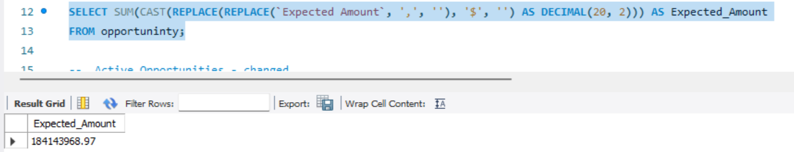

1. **Active Opportunities**

select Count(Closed) as Active_Opportunities

from opportuninty

where Closed = 'False';

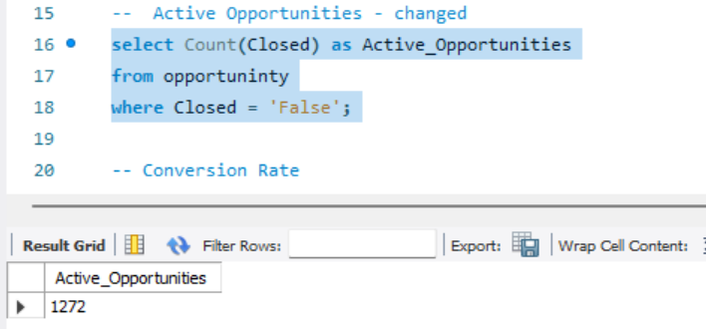

1. **Conversion Rate**

select

(SUM(CASE WHEN `Created by Lead Conversion1` = '1' THEN 1 ELSE 0 END) * 100.0) / COUNT(*) AS Conversion_Rate_Percentage

from opportuninty;

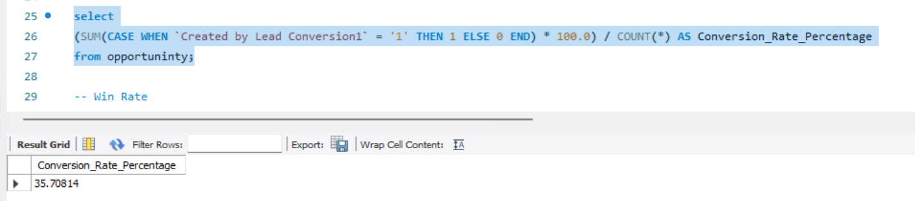

1. **Win Rate**

select

(SUM(CASE WHEN `Winrate` = '1' THEN 1 ELSE 0 END) * 100.0) / COUNT(*) AS Conversion_Rate_Percentage

from opportuninty;  
  
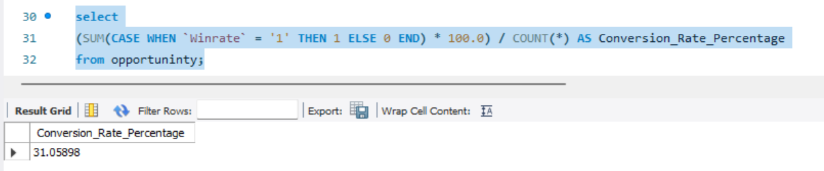

1. **Loss**

select

(SUM(CASE WHEN `Lossrate` = '1' THEN 1 ELSE 0 END) * 100.0) / COUNT(*) AS Conversion_Rate_Percentage

from opportuninty;

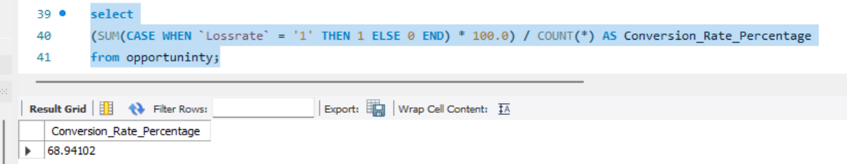

**Trend Analysis**

1. **Running Total Expected Vs Commit Forecast Amount over Time**

SELECT

`Fiscal Year`,

`Expected Amount`,

SUM(`Expected Amount`) OVER (ORDER BY `Fiscal Year` ASC) AS Running_Total_Expected,

SUM(`Forecast Q Commit1`) OVER (ORDER BY `Fiscal Year` ASC) AS Running_Total_Commit_Forecast

FROM

opportuninty

ORDER BY

`Fiscal Year` ASC;  
  
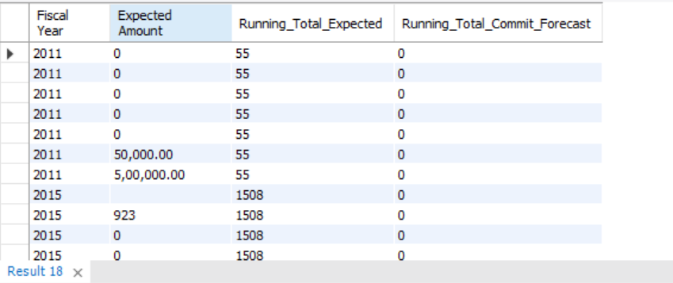

1. **Running Total Active Vs Total Opportunities over Time**

SELECT

`Fiscal Year`,

COUNT(*) AS Total_Opportunities,

SUM(`Active Opp`) AS Active_Opportunities,

SUM(COUNT(*)) OVER (ORDER BY `Fiscal Year` ASC) AS Running_Total_Opportunities,

SUM(SUM(`Active Opp`)) OVER (ORDER BY `Fiscal Year` ASC) AS Running_Total_Active_Opportunities

FROM

opportuninty

GROUP BY

`Fiscal Year`

ORDER BY

`Fiscal Year` ASC;

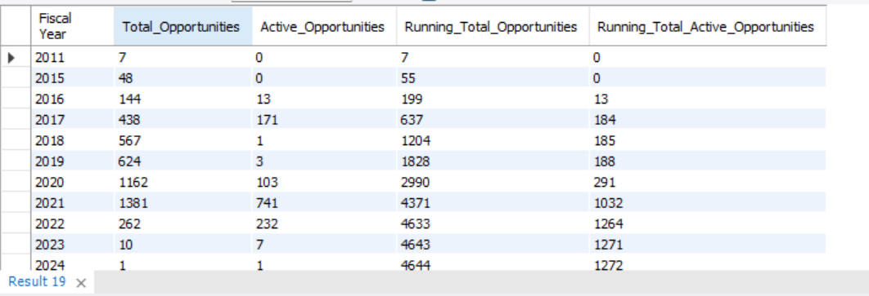

1. **Closed Won Vs Total Opportunities over Time**

SELECT

`Fiscal Year`,

COUNT(*) AS Total_Opportunities,

SUM(CASE WHEN `stage` = 'Closed Won' THEN 1 ELSE 0 END) AS Closed_Won_Opportunities,

SUM(COUNT(*)) OVER (ORDER BY `Fiscal Year` ASC) AS Running_Total_Opportunities,

SUM(SUM(CASE WHEN `stage` = 'Closed Won' THEN 1 ELSE 0 END)) OVER (ORDER BY `Fiscal Year` ASC) AS Running_Total_Closed_Won

FROM

opportuninty

GROUP BY

`Fiscal Year`

ORDER BY

`Fiscal Year` ASC;  
  
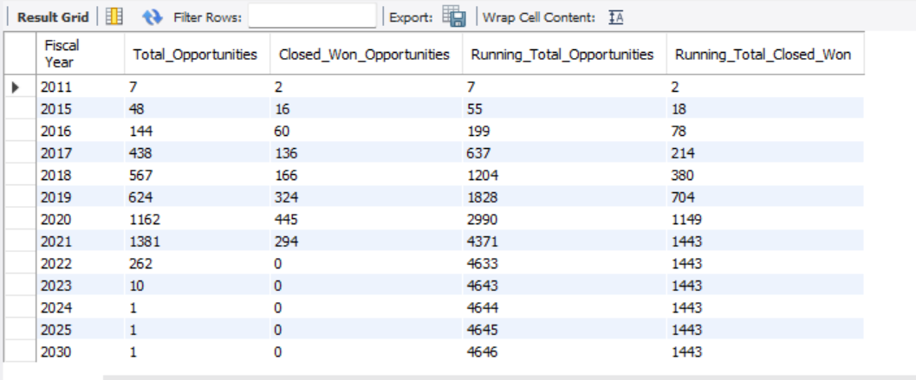

1. **Closed Won vs Total Closed over Time**

SELECT

`Fiscal Year`,

SUM(CASE WHEN `Closed` = 'True' THEN 1 ELSE 0 END) AS Total_Closed_Opportunities,

SUM(CASE WHEN `Stage` = 'Closed Won' THEN 1 ELSE 0 END) AS Closed_Won_Opportunities,

SUM(SUM(CASE WHEN `Closed` = 'True' THEN 1 ELSE 0 END)) OVER (ORDER BY `Fiscal Year` ASC) AS Running_Total_Closed_Opportunities,

SUM(SUM(CASE WHEN `Stage` = 'Closed Won' THEN 1 ELSE 0 END)) OVER (ORDER BY `Fiscal Year` ASC) AS Running_Total_Closed_Won

FROM

opportuninty

GROUP BY

`Fiscal Year`

ORDER BY

`Fiscal Year` ASC;  
  
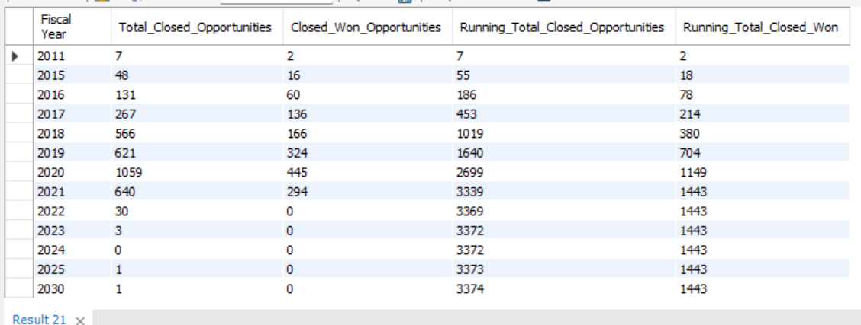

1. **Expected Amount by Opportunity Type**

SELECT `Opportunity Type`, sum(Amount) AS Amount_genrated

FROM opportuninty

GROUP BY `Opportunity Type`;  
  
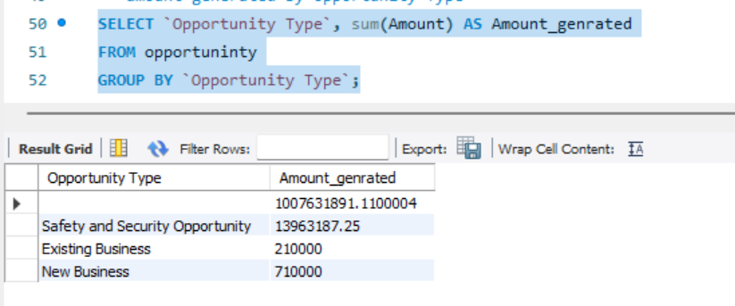

1. Opportunities by Industry

SELECT `Industry`, count(CASE WHEN `Active Opp` = '1' THEN 1 ELSE 0 END) AS total_opp

FROM opportuninty

GROUP BY `Industry`

ORDER BY total_opp DESC ;

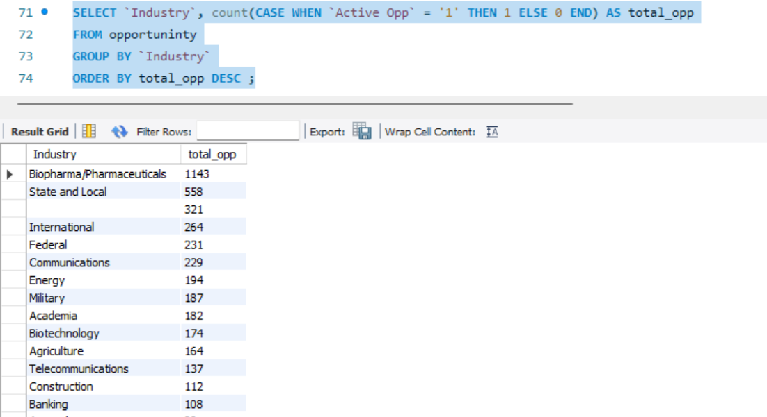

**Additional Key point’s**

* **actual difference between expected amount and Actual amount**

SELECT

`Opportunity Type`,

SUM(`Expected Amount`) AS Expected_Amount,

SUM(Amount) AS Amount_generated,

SUM(`Expected Amount`) - SUM(Amount) AS difference

FROM

opportuninty

GROUP BY

`Opportunity Type`;  
  
